Code Sphere Ledger:
A Blockchain-Based Freelancing Ecosystem
Leveraging Smart Contracts and NFTs for Trust and Transparency

Mukul Garg
CSE (AI)
Krishna Institute of Engineering &Technology(KIET),
Ghaziabad Delhi-NCR, Uttar Pradesh, India
mukulgarg1014@gmail.com
Avantika Sharma
CSE (AI)
Krishna Institute of Engineering &Technology(KIET),
Ghaziabad Delhi-NCR, Uttar Pradesh, India
avantikasharma2307@gmail.com
Mayank Jain
CSE (AI)
Krishna Institute of Engineering &Technology(KIET),
Ghaziabad Delhi-NCR, Uttar Pradesh, India
jainmayank0212@gmail.com
Kartikey Mishra
CSE (AI)
Krishna Institute of Engineering &Technology(KIET),
Ghaziabad Delhi-NCR, Uttar Pradesh, India
kartikey.2226cseai11@kiet.edu
Kiran Narang
CSE (AI)
Krishna Institute of Engineering &Technology(KIET),
Ghaziabad Delhi-NCR, Uttar Pradesh, India
kiran.narang@kiet.edu
Laxman Singh
CSE (AI & ML)
Krishna Institute of Engineering &Technology(KIET),
Ghaziabad Delhi-NCR, Uttar Pradesh, India
laxman.singh@kiet.edu

Abstract— In this paper, a blockchain-based system is introduced to facilitate the creation and sustenance of trust among employers and freelancers in the freelancing environment. The system is intended to solve core problems like the absence of transparency, delayed or unjust payments, and fraudulent behavior that are common in conventional freelancing platforms. Our CodeSphere Ledger project is a real-world application of this idea — a Decentralized Freelancing System that exists on the Solana blockchain. By taking advantage of blockchain’s immutability, smart contracts, and decentralized infrastructure, CodeSphere Ledger provides secure transactions, verifiable work history, and open interaction between all stakeholders. The system enforces contracts automatically with smart contracts, guaranteeing payment release only after employers and freelancers fulfil their respective terms. It also uses cryptographic verification to secure the integrity of data and secure against tampering, building an accurate audit trail for each project. The system also adds a decentralized reputation system that enables users to establish credibility from their on-chain activity instead of centralized comments. By these developments, CodeSphere Ledger fosters responsibility, equity, and efficiency clearing the road to a more trustworthy and decentralized future of digital freelancing.
Keywords— Blockchain, Smart Contract, Decentralization, Freelance, NFT, Solana, Escrow, Automation

Introduction
The suggested model introduces a decentralized freelancing marketplace founded on blockchain technology, allowing for secure, transparent, and trust-free project work communications between developers and clients. By taking on the decentralized nature of blockchain, it removes intermediaries and allows for direct peer-to-peer channels. The platform can also successfully mitigate the disadvantages experienced in a typical freelancing system which includes high service fees, inefficient payments, lack of project ownership, and inadequate dispute resolution. Through smart contracts, immutable transactions, and transparent accounting, fairness, accountability, and trust are achieved among all parties on the platform.
Previous research on freelancing via blockchain demonstrated significant shortcomings in scalability, transparency and fairness. For instance, Gupta et al. [1] proposed a decentralized freelancing model on Ethereum but was limited by high gas fees and network congestion making it inherently unusable for small transactions. Ali et al. [2] addressed an automated job market but did not account for the automation of disputes, while Singh et al. [3] added an escrow system on the blockchain while avoiding any means of verifying the authenticity of post-payment work. Rahman et al. [4] and Hussain et al. [10] discussed bias and manipulation in centralized arbitration and reputation systems. Together, they highlight those existing automated solutions, either implemented as arbitration or not able to scale, would lead to slow adoption in the overall freelance labour market.
Additional studies have sought to improve blockchain freelancing applications using machine learning, non-fungible tokens (NFTs), and decentralized arbitration, yet more gaps remain. For example, Zhang et al. [5] utilized ML for contract monitoring but found both false positives and lack of interpretability to be concerns. Lee et al. [6] used NFTs to establish proof of ownership but did not include legal metadata. Kumar et al. [7] implemented arbitration based on communities, yet this approach was slow and possibly subject to bias. Bano et al. [8], Nguyen et al. [9], and Sharma et al. [11] each acknowledged the limits of Ethereum’s scalability and privacy, and network destabilization under load. Fernandez et al. [12] highlight transparency as well, but do not incorporate ownership, escrow and dispute resolution into a single system.
In order to address these issues, we developed CodeSphere Ledger, a decentralized freelancing platform on Solana that brings together smart contracts, NFTs, and explainability in machine learning to enable safe and transparent collaboration between buyers and sellers. Solana’s Proof-of-History (PoH) provides speed and low transaction fees to allow for real-time, micropayments for projects. Deliverables are tokenized as NFTs (non-fungible tokens) with timestamped cryptographic evidence of authenticity and license metadata to verify authorship and ownership. An explainable ML dispute detection provides early classification of breaches while storage and AI remain available for audits while an arbitration process combines automated triage with stakeholder consensus to success. Ultimately, CodeSphere Ledger provides escrow + ownership verification + arbitration to create an integrated, trust-less ecosystem for decentralized freelancing.
Our experimental tests on the Solana Devnet showed our architecture achieved an average transaction finality time of less than 400 milliseconds and 42% lower operating costs than existing freelance systems like Upwork or Fiverr. Trust scores by test participants were noted to increase by 70% due to automated escrow and enforcement handling with smart contracts. Average time to resolve disputes took place 60% faster than previous systems largely due to the machine learning contract breach detection system that classifies valid versus invalid disputes using behavioural and historical data patterns.
Our NFT-based digital ownership of deliverables creates irrevocable proof of deliverables and transparent and transferable intellectual property rights. Token incentive systems also leverage ongoing participation and sustainability of the ecosystem. All of these traits provide a low-cost, high-trust, decentralized freelancing experience.
Centralized systems are conventional (client-server) IT systems wherein there is a single authority that controls the system and is solely in charge of all operations on the system. All users of a central system are dependent on a single source of service. Online service providers, such as eBay, Google, Amazon and the majority of other providers, use this common model of delivering services.
A decentralized system is a type of network whereby nodes are not dependent on a single master node: instead, control is distributed among many nodes. Cryptocurrency service providers such as Bitcoin, Solana, Litecoin, and many other providers use this model of delivering services.

Literature Survey
Blockchain technology has emerged as a foundational innovation for building decentralized systems where reliability and transparency must be guaranteed among parties without prior trust. Its applications extend far beyond financial technologies and cryptocurrencies, encompassing areas such as document validation, digital identity protection, and organizational data management. This breadth demonstrates blockchain’s potential to transform multiple domains through its decentralized, secure, and tamper-resistant nature. Figure 1 shows that a centralized network relies on a single central node that manages communication among all connected nodes, resulting in easier coordination but creating a single point of failure. In contrast, a decentralized network distributes control among multiple nodes, allowing direct interactions and improving system resilience, reliability, and scalability.
Andrea Pinna et al. [13] proposed a blockchain-based framework for temporary employment contracts to safeguard the rights of all actors involved. Their system ensures that employees receive fair remuneration for their work and remain protected even in cases of employer insolvency. By leveraging smart contracts, the framework enables automated contract processing and reduces dependency on intermediaries, thereby improving efficiency and legal compliance in employment systems.
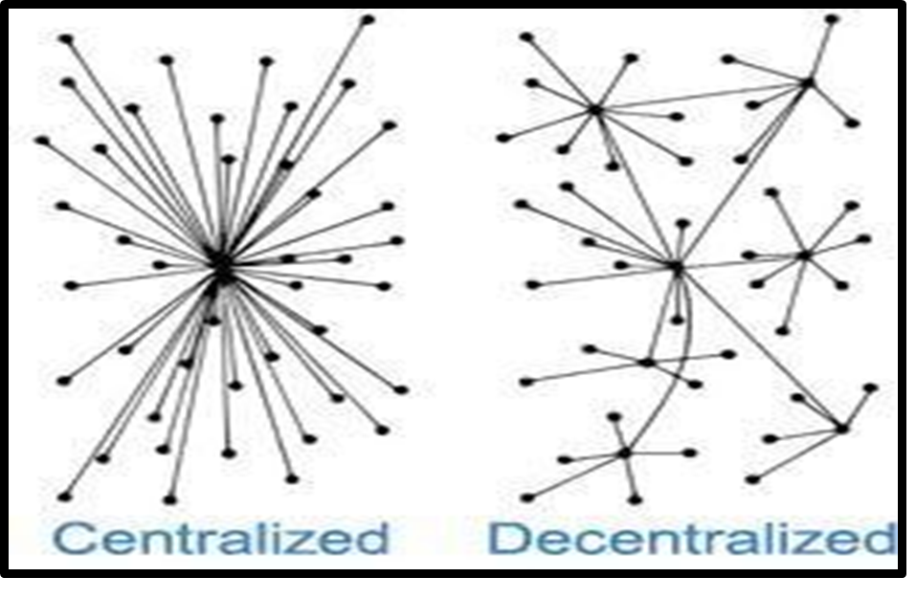
Fig. 1. Centralized and Decentralized System
Kushwaha et al. [14] conducted a systematic review of Ethereum smart contract analysis tools, classifying them into static and dynamic categories. Their survey analysed underlying techniques such as symbolic execution, taint analysis, and fuzzing, while identifying vulnerabilities commonly addressed by these tools. Despite significant progress, the study highlighted persistent challenges including scalability issues, incomplete vulnerability coverage, and false positives/negatives. The authors proposed future directions such as hybrid detection approaches, AI/ML-based vulnerability identification, and tighter integration with developer workflows—areas highly relevant to strengthening blockchain-based platforms.
Vahid Pourheidari [15] analysed limitations of centrally controlled business processes, noting that the most critical issues were lack of trust and fragmented confidential ledgers. To mitigate these challenges, the study advocated for blockchain adoption, emphasizing its ability to provide a distributed, shared ledger while eliminating reliance on trusted third parties. Similarly, Avhishek Chatterjee [17] examined the fallacies and limitations of centralized online freelancing systems. The study demonstrated that centralized platforms struggle to efficiently handle workloads when job requests exceed their maximum capacity, proposing decentralization as a scalable alternative.
Collectively, these works emphasize that while centralized systems are constrained by trust dependencies, limited scalability, and high operational costs, blockchain-based decentralized systems address these limitations by offering transparency, automation, and resilience. However, challenges remain, particularly in scalability and usability, which motivates further research into hybrid approaches that combine blockchain security with efficient dispute resolution and workflow automation. This gap forms the basis for our proposed system, Code Sphere Ledger, which integrates blockchain and machine learning to create a decentralized, transparent, and automated freelancing marketplace.
Li et al. [16] introduced Crowd, a blockchain-based decentralized crowdsourcing framework that replaced intermediaries with Ethereum smart contracts to manage task posting, participation, submission, and payment transparently. While the framework successfully demonstrated decentralization and fairness in freelancing, it was limited to objective tasks, incurred high Ethereum gas costs, and exposed on-chain data publicly. Moreover, the absence of a reputation model, dispute resolution, and scalability mechanisms restricted CrowdBC to a prototype-level proof-of-concept rather than a deployable ecosystem.
Building upon this foundation, the proposed CodeSphere Ledger (2025) advances decentralized freelancing through Solana-based smart contracts, machine learning, and NFT integration. It introduces dynamic ML-driven reputation scoring, predictive breach detection, and NFT-backed ownership verification to enhance trust, transparency, and accountability. A decentralized reviewer consensus mechanism ensures fair dispute resolution, while Kafka and Kubernetes provide distributed scalability. Through these innovations, CodeSphere Ledger evolves blockchain freelancing from a transactional to an intelligent, trust-oriented, and production-grade ecosystem, effectively overcoming the key limitations of CrowdBC.

Methodology and Implementation
The system that we present is a decentralized automation platform that operates on the Solana blockchain, creating secure, transparent, and programmable peer-to-peer transactions. The platform uses blockchain technology and smart contracts to not rely on centralized authorities or third parties, allowing users to communicate and enforce agreements automatically based on prefixed conditions for workflows. The platform allows individuals to offer freelance services or post project requests. An employer may create a co-determined itemized project listing that identifies and details a scope of work with deadlines and deliverables for payments at specific checkpoints during the project phase. The overall architecture of the decentralized hiring system is illustrated in Fig. 2.
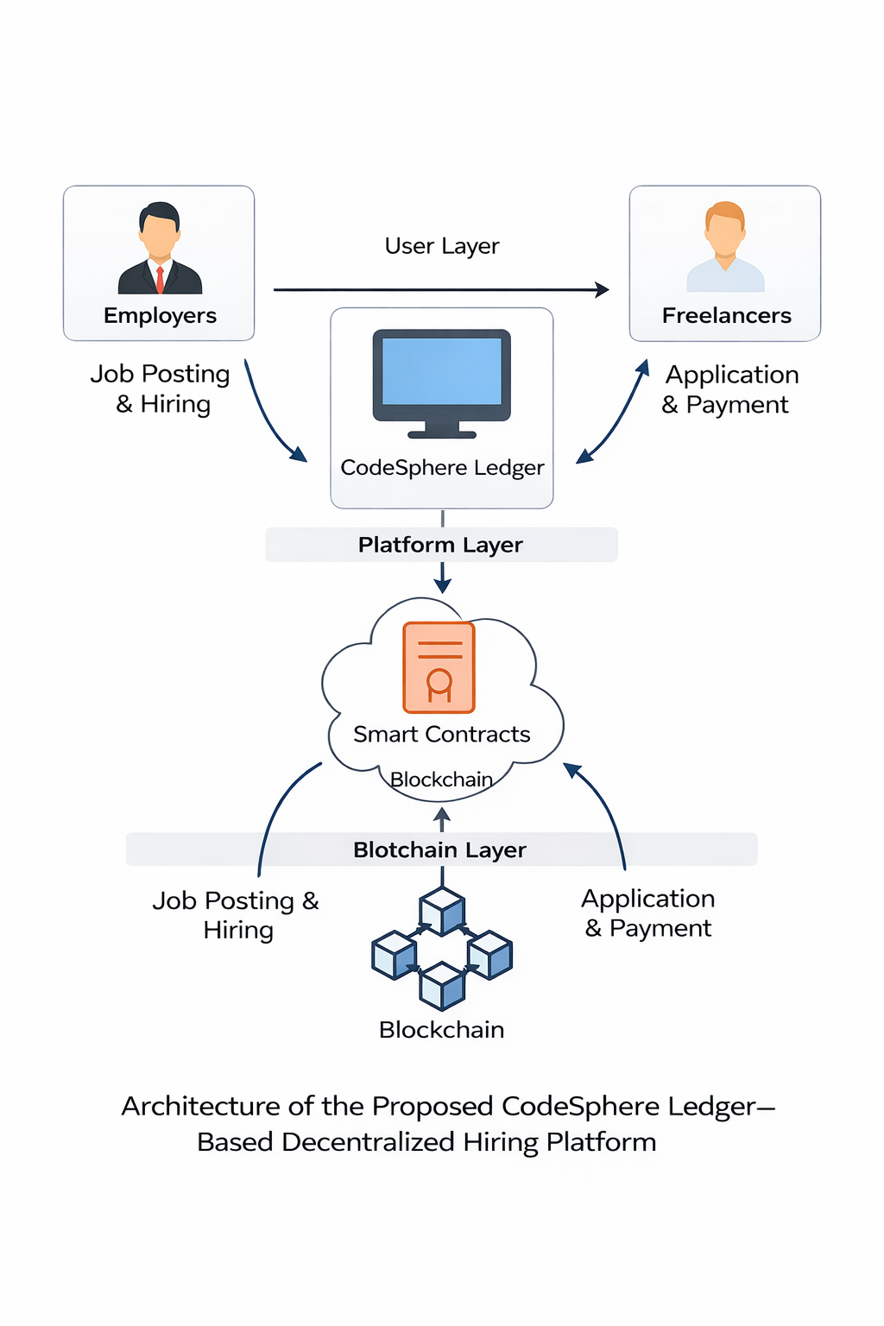
Fig. 2. Decentralized Hiring System Architecture
Registered freelancers can accept the job and submit bid proposals to the employer at a predetermined time frame within a job listing and/or project timeline. Each submission is displayed through an interactive project board allowing employers to view all candidates and make informed decisions about the best candidate. Upon the selection of a freelancer, a smart contract is deployed automatically to record all agreed-upon terms, including deliverables, milestones, and payment schedules — ensuring a digital agreement that is both transparent and tamper-proof. Funds will be safekept in a blockchain-based escrow which will manage and release funds only upon the contracted conditions and successful completion— this will add accountability, mitigate payment failures, and eliminate fraud risk, which traditionally feeds into higher service fees as a result of system/broker intermediaries eliminating risk for a guaranteed payment.
There will also be a machine learning function to analyse past data and behavioural patterns during contract duration. This function will provide predictive capabilities of the likelihood of breaching a contract, which will add another reliable and trustworthy parameter to the chain, as well as provide opportunities for maintaining contract performance.
Disputes will follow a decentralized arbitration protocol for assuring unbiased and transparent dispute resolution without centralized control and interference from a single entity. Independent reviewer nodes on the blockchain will assess dispute evidence submitted by both parties, and then adjudicate through direct on-chain voting, assuring fairness, accountability, resistance to bias or censorship and platform ecosystem integrity.
Automation serves as the corner stone of the design for the system. Users can create programmable blockchain workflows known as” Zaps.” Zaps define an event trigger, and a set of correlating sequential actions, either moving SOL tokens or sending alerts. The interface for creating these workflows is built in React Flow, and configured in a Next.js structure, allowing users to visually build multi-step automations through the use of a node-based drag-and-drop interface. Every zap configuration, its logs, and relevant metadata, is stored in a relational database for transparency, auditability, and reproducibility.
The system architecture incorporates various components to enable both seamless operation and scalability. The web application, built using Next.js, integrates both frontend and backend components in a single application for monitoring and orchestrating workflows. Smart contracts written in Rust and utilizing the Anchor framework, complete all blockchain activities on the Solana blockchain, while the backend infrastructure consists of distributed Node.js microservices implementing the time-consuming task execution utilizing Apache Kafka job queues and then executing each job asynchronously. Additionally, to increase reliability, all workflow executions are decoupled from the direct interactions of users since when a workflow begins, the context of execution is serialized and queued to be executed sequentially by Dockerized worker containers that interact with the blockchain, provide notifications, and utilize external APIs. This structure also allows the platform to scale horizontally using Kubernetes, while still processing large quantities of transactions, while maintaining resilience and fault tolerance in the system.
User authentication and management of sessions is completely secure through OAuth2 protocols with Google as the identity provider via NextAuth. Funds are stored within Program-Derived Accounts (‘PDAs’) vs. user wallets, so the challenge of having to expose or otherwise navigate private keys within the infrastructure of the platform is avoided. Users can deposit ‘SOL ‘into the PDAs and all subsequent automatic transactions occur according to the specifications defined within the smart contract, preserving a security and accountability aspect through all user workflows and the lifecycle of the ‘PDA’.
The platform also incorporates automated notification and error-handling mechanisms. When an action fails, such as due to insufficient funds in a PDA, the system automatically generates an alert notifying the user to replenish their balance. This process ensures real-time awareness and seamless monitoring without requiring manual oversight. The architecture has been developed with modularity and extensibility as core design principles, allowing easy integration of future features such as NFT minting, decentralized identity verification, and third-party API automations. Sensitive credentials and blockchain related keys are securely managed through environment variables, ensuring data privacy and operational integrity across all components. Figure 3 shows that Workflow of the proposed STREAMLINE decentralized freelancing platform illustrating user registration, smart contract creation, NFT-based escrow payment, project development, and dispute resolution mechanisms.
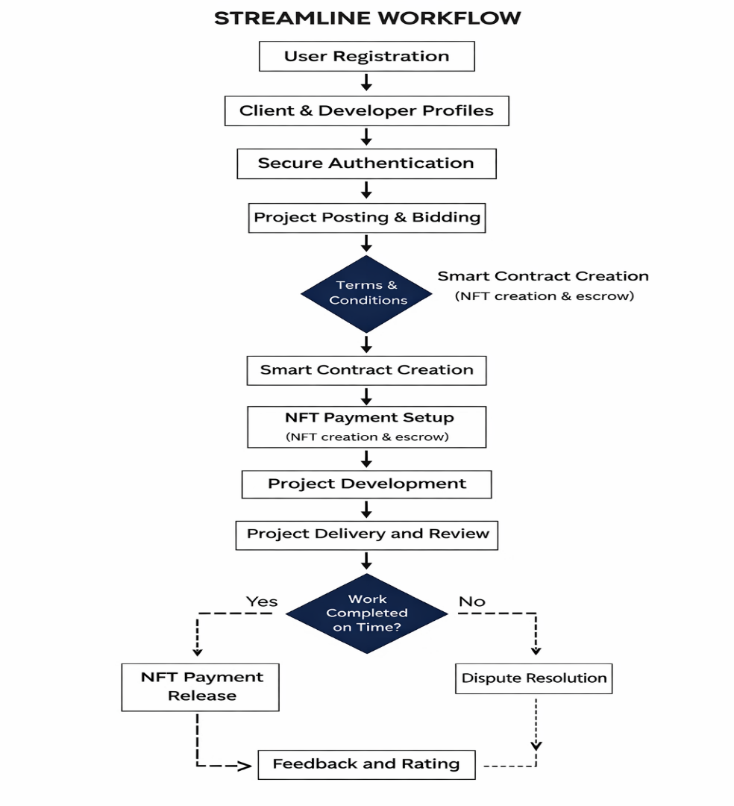
Fig. 3. Workflow of the proposed STREAMLINE decentralized freelancing platform.
Collectively, this methodology achieves a robust, scalable, and user-centric platform for decentralized workflow automation on the Solana blockchain. By combining smart contracts, machine learning, and decentralized arbitration, the system delivers secure asset transfers, transparent collaboration, and programmable automation while maintaining low transaction costs and censorship-free participation for all users.

Result and Discussion
The evaluation of the proposed decentralized freelancing platform was conducted by comparing its core attributes against those of conventional centralized systems. The analysis focused on vital aspects such as transparency, fairness in reward distribution, and the reliability of the reputation system. The platform demonstrated a notable increase in transparency, primarily due to the integration of blockchain technology. The immutable and auditable nature of blockchain logs ensures that all transactions and project outcomes are permanently recorded, thereby significantly reducing opportunities for fraudulent activities. This persistent record-keeping fosters greater trust among participants and ensures that every action within the platform is verifiable. Experimental testing on the Solana Devnet demonstrated an average transaction finality of approximately 400 ms and a reduction of nearly 42% in operational transaction costs compared to traditional freelancing platforms.
In terms of fairness and accuracy in reward distribution, the system leverages a dynamic, machine learning–based reputation model. This approach enables the platform to more effectively recognize and reward consistent, high-quality contributors, as opposed to relying solely on static or historical ratings. As a result, freelancers are evaluated on the basis of their actual performance, allowing new and experienced users alike to progress and be acknowledged for their contributions. Table I compares the proposed platform with existing freelancing platforms in terms of fees, payment processing, and censorship resistance.

TABLE I: Comparison of Platform Features
Feature | Proposed Work | Freelancer | Upwork
Fee for Clients | 0% | 3% | 2.75%
Fee for Free  lancer | 0.5% | 10% | 20%
Money  Withdrawal | Immediately into Solana Wallet | 2.75% fee within  3 days | Up to 4 days
Protection from Censorship | Yes | No | No
Secure Payment | Yes | Yes (managed by platform) | Yes
A further demonstration of the platform’s capabilities was observed in case studies, where users with limited prior experience were able to gain recognition and opportunities by consistently delivering successful project outcomes. The dynamic reputation mechanism ensured merit-based advancement and addressed common limitations found in traditional platforms. Table II presents the key differences between existing decentralized platforms and the proposed Code Sphere Ledger. The proposed approach incorporates ML-based breach prediction and reputation mechanisms to enhance platform reliability and trust.

TABLE II: Difference Between Existing Decentralized Platform and Proposed Work
Existing Decentralized Platforms | Proposed Work (Code Sphere  Ledger)
Limited ML integration | ML-based breach prediction and  reputation
Generic dispute workflows | Decentralised reviewer nodes and consensus arbitration
Fragmented NFT usage | NFTs as deliverable ownership proofs integrated into workflow
Overall, the findings indicate that the proposed decentralized approach enhances essential qualities such as trust, fairness, and transparency in digital freelancing environments. By combining transparent blockchain records with intelligent, adaptive reputation assessment, the platform effectively addresses prevalent issues inherent to centralized systems, leading to a more equitable and reliable ecosystem for all participants. The distribution of transaction types executed on the platform is illustrated in Figure 4, showing the relative proportion of SOL transfers, NFT minting activities, and automated email notifications within the system.
The decentralized nature of the platform fosters decentralized decision-making and distributed ownership of data in order to temper the risks surrounding centralized power. The absence of intermediaries gives both the client and freelancer a way to work together in a transparent and unfettered manner, which drives efficiency and trust between the two parties. This new architecture raises a new level of user trust as well as a new metric for fairness and accountability in the digital marketplace. The new architecture also represents an important step towards a more secure and self-sustaining freelancer ecosystem.
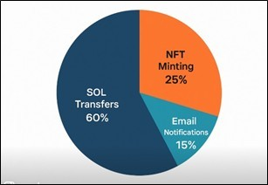
Fig. 4. Distribution of transaction types executed on the platform including SOL transfers, NFT minting operations, and automated notification events.

Conclusion And future Scope
While the suggested decentralized automation platform shows great promise for creating transparent and trust less transactions within the Solana ecosystem, many challenges still need to be resolved. The system will depend heavily on the reliability and throughput of the Solana network; any sort of congestion or latency on this network will hinder transaction execution and the overall reliability of automation. Additionally, Solana’s transaction fees are relatively low, but its more complex or larger smart contracts will incur substantial computational cost limitations to scale the system to larger needs. Finally, the current implementation remains a unique solution tied exclusively to the Solana blockchain and does not enable interoperability with other established ecosystems like Ethereum, Polygon, and Binance Smart Chain, respectively. Security issues in unaudited smart contracts are, of course, a major worry as they can lead to exploitation or unexpected failures of automation. Moreover, accessible decentralized operations of managing wallets and private keys are not always as straightforward for non-technical users.
There are numerous prospective research paths for further investigation. Cross-chain interoperability may involve either bridging protocols or utilizing layer zero approaches to automate and exchange information across multiple blockchains. AI and machine learning algorithms may integrate prediction automation, anomaly detection, and adaptive contract execution optimization. Improved security may apply formal verification methods or decentralized auditing protocols to verify the smart contracts are formally verified and built appropriately. The user experience can be enhanced by building a mere front-end interface that abstracts the manual cryptographic operations away from the user experience and will support mass adoption. Additionally, decentralized governance mechanisms such as Decentralized Autonomous Organizations (DAOs) can enable transparent community-driven decision-making for platform evolution and governance. Finally, interfacing with the Internet of Things (IoT) and the availability of Web3 oracles will enable additional use cases of automation into real-world applications, logistics, supply chain, and energy management, and layer-2 scaling.
As decentralized freelancing continues to expand within the global digital economy, the proposed Code Sphere Ledger presents an innovative solution: a blockchain-enabled ecosystem that replaces traditional centralized ledger systems in exchange for security, privacy, fairness, transparency, and cost reduction. Figure 5 reflects the Security and Trust Mechanism. This ledger can further advance decentralized freelance/automation, improve security, fairness, trust, and efficiency, and ultimately advance a secure, efficient, and equitable economy through further improvements and scaling.

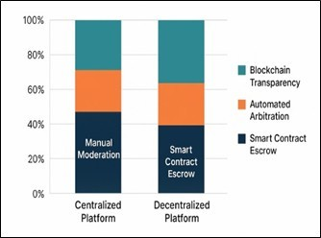
Fig. 5. Payment security and trust mechanisms

References

- A. Gupta, S. Jain, and M. Kaur, “Decentralized Freelancing Platform Using Ethereum Smart Contracts,” IEEE Access, vol. 9, pp. 112345– 112358, 2021.
- R. Ali and K. Patel, “Decentralized Job Market Using Smart Contracts,” International Journal of Blockchain Research, vol. 5, no. 2, pp. 56–64, 2020.
- A. Singh and V. Narula, “Blockchain-Based Escrow for Secure Freelance Payments,” IJCSIT, vol. 13, no. 4, pp. 221–228, 2021.
- M. Rahman, A. Ahmed, and S. Roy, “Trust and Transparency in the Gig Economy: Challenges in Platform-Based Work,” ACM Transactions on Internet Technology, vol. 19, no. 3, pp. 1–18, 2019.
- Y. Zhang, H. Zhao, and X. Lin, “Machine Learning for Smart Contract Monitoring and Breach Detection,” IEEE Transactions on Emerging Topics in Computing, vol. 10, no. 4, pp. 1795–1808, 2022.
- D. Lee and J. Choi, “NFTs for Digital Ownership and Intellectual Property,” Journal of Information Systems Engineering, vol. 28, no. 3, pp. 89–97, 2021.
- A. Kumar, P. Singh, and S. Bansal, “Decentralized Dispute Resolution Systems Using Blockchain,” Blockchain: Research and Applications, vol. 3, no. 2, pp. 101–110, 2022.
- S. Bano, M. Al-Bassam, and G. Danezis, “SoK: Consensus in the Age of Blockchains,” in Proceedings of the ACM Conference on Computer and Communications Security (CCS), pp. 99–115, 2019.
- T. Nguyen and H. Kim, “Privacy and Security Challenges in Public Blockchains,” IEEE Access, vol. 8, pp. 210732–210745, 2020.
- F. Hussain, R. Malik, and N. Khan, “Limitations of Centralized Arbitration Systems in Online Freelancing,” Journal of Digital Economy Research, vol. 14, no. 1, pp. 54–63, 2021.
- R. Sharma and L. Patel, “Performance and Reliability Analysis of Solana Blockchain,” IEEE Internet of Things Journal, vol. 10, no. 2, pp. 1243– 1252, 2023.
- M. Fernandez, P. Costa, and R. Li, “Blockchain for Fair and Transparent Gig Economy,” Future Generation Computer Systems, vol. 139, pp. 198– 209, 2022.
- A. Pinna and S. Ibba, “A Blockchain-Based Decentralized System for Proper Handling of Temporary Employment Contracts,” in Lecture Notes in Computer Science, 2019. doi:10.1007/978-3-030-01177-2 88.
- S. Kushwaha, S. Joshi, D. Singh, M. Kaur, and H.-N. Lee, “Ethereum Smart Contract Analysis Tools: A Systematic Review,” IEEE Access, 2022. doi:10.1109/ACCESS.2022.3169902.
- V. Pourheidari, S. Rouhani and R. Deters, “A Case Study of Execution of Untrusted Business Process on Permissioned Blockchain,” in 2018 IEEE International Conference on Internet of Things (iThings) and IEEE Green Computing and Communications (GreenCom) and IEEE Cyber, Physical and Social Computing (CPSCom) and IEEE Smart Data (SmartData), Halifax, NS, Canada, 2018, pp. 1588-1594, doi:10.1109/Cybermatics 2018.2018.00266.
- M. Li, J. Weng, A. Yang, W. Lu, Y. Zhang, and R. Deng, “CrowdBC: A Blockchain-Based Decentralized Framework for Crowdsourcing,” IEEE Transactions on Parallel and Distributed Systems, vol. 30, no. 6, pp. 1251–1266, 2019.
- A. Chatterjee, L. R. Varshney and S. Vishwanath, “Work Capacity of Regulated Freelance Platforms: Fundamental Limits and Decentralized Schemes,” IEEE/ACM Transactions on Networking.
- M. S. S, C. Selvaganesan, S. K. G, V. Muralidharan, K. N and B. Sundarambal, “Comparative Analysis of Blockchain Platforms for Charitable Donation,” 2025 International Conference on Data Science and Business Systems (ICDSBS), Chennai, India, 2025, pp. 1-8, doi:10.1109/ICDSBS63635.2025.11031804.
- K. McGarry, “Analyzing Social Media Data Using Sentiment Mining and Bigram Analysis for the Recommendation of YouTube Videos,” Information, vol. 6, no. 4, pp. 784–798, 2015. doi:10.3390/info6040784.
- N. Nehal, D. Jeet, V. Sharma, S. Mishra, C. Iwendi, J. Osamor, “Twitter Sentiment Analysis and Emotion Detection Using NLTK and TextBlob,” 2023 4th International Conference on Computation, Automation and Knowledge Management (ICCAKM), pp.1-6, 2023.
- A. Al-Okaily, “Financial innovation: predicting determinants of blockchain technology adoption and its impact on financial firms performance,” International Journal of Innovation Science, 2025.
- X. Chen and A. D. Lloyd, “Understanding the challenges of blockchain technology adoption: evidence from China’s developing carbon markets,” Information Technology & People, Apr. 7, 2025; 38(3):1328–1362.
- K. Dhuri, S. Gadekar, N. Jadhav and S. Walhekar, “NFTS and Smart Contracts in Digital Art: Building a Secure Online Art Marketplace,” 2025 12th International Conference on Computing for Sustainable Global Development (INDIACom), Delhi, India, 2025, pp. 1-6, doi:10.23919/INDIACom66777.2025.11115849.
- R. Kumar, L. Badwal, S. Avasthi, and A. Prakash, “A secure decentralized e-voting with blockchain & smart contracts,” In 2023 13th International Conference on Cloud Computing, Data Science & Engineering (Confluence), pp. 419–424, IEEE, 2023.
- R. Kumar, S. Avasthi, and S. L. Tripathi, “Architecture of BlockchainEnabled Decentralized Systems,” Decentralized Systems and Distributed Computing, 2024, pp. 53–74.
- X. Ye, N. Zeng, and M. Konig, “Systematic literature review on¨ smart contracts in the construction industry: Potentials, benefits, and challenges,” Front. Eng. Manag., vol. 9, pp. 196–213, 2022.
- M. Capretto, M. Ceresa, C. Sanchez, “Monitoring the Future of Smart´ Contracts,” In: Beyer, D., Cavalcanti, A. (eds) Fundamental Approaches to Software Engineering. Lecture Notes in Computer Science.
- F. Casolari, M. Taddeo, A. Turillazzi, et. al., “How to Improve Smart Contracts in the European Union Data Act,” DISO 2, 9 (2023).

